PUBLICITY INFORMATION AND ROOM ARRANGEMENTS

Name of Program: Stevens Puppets

Performer Name : Dan Raynor

Program Title: The Legend of Sleepy Hollow

Background:

ENCHANTING! OUTSTANDING! HILARIOUS! EXCEPTIONAL! FANTASTIC!
These are but a few of the wonderful things teachers, librarians, and PTO chairpersons in the Greater Washington area are using to describe the incomparable Stevens Puppets! Setting the bar for puppetry arts not only regionally but nationally, the critically acclaimed Stevens Puppets have truly become a NATIONAL TREASURE! Triumphantly celebrating over 80 years of producing unforgettable and one of a kind marionette productions for children of all ages. These marionettes were authentically created in the traditional old world style, specializing in classic children's literature, and classic fairy tales. All of the programs are intended for all age levels. All of the stories are educational and have a moral or life skill woven cleverly and discretely throughout.
Description of Program:

The Legend of Sleepy Hollow--In this silly and non scary version of Washington Irving's classic piece of literature, children of all ages will follow the lanky school master, Ichabod Crane, as he sings, dances, and falls in love with a Giggly, Katrina Van Tassel. Students will watch breathless as Katrina's father, Baltus, and the village goof ball, Brom Bones, try to run Ichabod out of town by telling him the tale of . . . The Headless Horseman. The Stevens Puppets bring this ever-popular classic tale delightfully to life with beautiful wooden marionettes. The entire production is underscored by classical music, and a fun time is had by all! Adapted for marionettes by Martin Stevens and Daniel Raynor

Length of Program: 45 Minutes (with a humorous marionette demonstration following the performance.)
Room arrangement needed: NO CENTER ISLE. Chairs (for adults) on the perimeter of the room leaving a large open area in the middle of the room for the children to sit on the floor. Preferable.
Set-up/Break Down Time Needed: 45 minutes (if possible).
Equipment/furniture needs: 1 large table (6-8 ft) and 3 chairs.
Other special needs: Help with carrying our equipment in and out. And a 110 outlet.

http://www.stevenspuppets.com to get pictures digitally from our site.

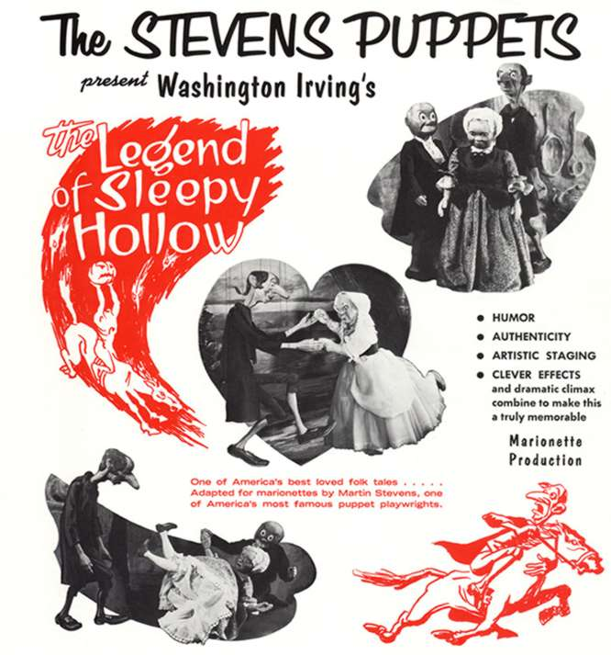

ENCHANTING! OUTSTANDING!

HILARIOUS! EXCEPTIONAL! FANTASTC!

These are but a few of the wonderful things people are saying about the Stevens Puppets!

- 81years of unforgettable, one-of-a-kind marionette productions
- Authentic, hand-carved old-world marionettes
- Intended for all ages
- Educational, character-based stories
More information at:
www.stevenspuppets.com

