PUBLICITY INFORMATION AND ROOM ARRANGEMENTS

Name of Program: Stevens Puppets

Program Title: Rumplestiltskin
Description of Program:

ENCHANTING! OUTSTANDING! HILARIOUS! EXCEPTIONAL! FANTASTIC!
These are but a few of the wonderful things teachers, librarians, and PTO chairpersons area are using to describe the incomparable Stevens Puppets! Setting the bar for puppetry arts not only regionally, but nationally, the critically acclaimed Stevens Puppets have truly become a NATIONAL TREASURE! Celebrating over 80 years of producing unforgettable and one of a kind marionette productions for children of all ages. These marionettes were authentically created in the traditional old world style, specializing in classic children's literature, and classic fairy tales. All of the programs are intended for all age levels. All of the stories are educational and have a moral or life skill woven cleverly and discretely throughout.

Rumplestiltskin This fast paced, action filled, rhyming rendition of the classic tale, follows the Miller as he weaves a web of lies to convince the King that his daughter can spin straw into gold! Enter the outrageously outspoken and never happy villain, Rumplestiltskin, whose preposterous demands create even more mayhem in the land of 'Stiltskin. Top it off with a "one of a kind" marionette that "flies to pieces" right before your eyes. Couple that with the Stevens Puppets touch of humor and authenticity, and you get one of the most highly rated, happily pleasing programs ever!

Length of Program: 45 Minutes (with a 5 minute demonstration after the show.)
Room arrangement needed: Chairs (for adults) on the perimeter of the room leaving a large open area in the middle of the room for the children to sit on the floor.
Set-up/Break Down Time Needed: 45 minutes (if possible).
Equipment/furniture needs: 1 large table (6-8 ft) and 3 chairs.
Other special needs: Help with carrying our equipment in and out. And a 110 outlet.

http://www.stevenspuppets.com to get pictures digitally from our site.

The King and Queen from Stevens Puppets Rumplestiltskin marionette play.

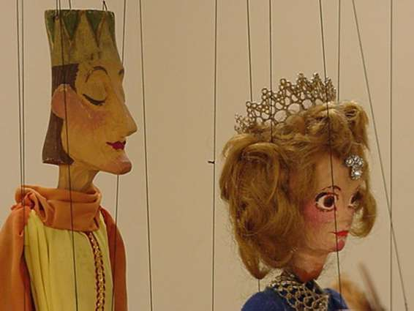

The cast of Stevens Puppets Rumplestiltskin marionette play.
