Read https://en.wikipedia.org/wiki/Geography_of_Alaska and complete this worksheet.

1. Write the names of the 6 oceans or seas around Alaska (in the blue boxes).
2. Write the names of the bordering countries to Alaska (in the red boxes).
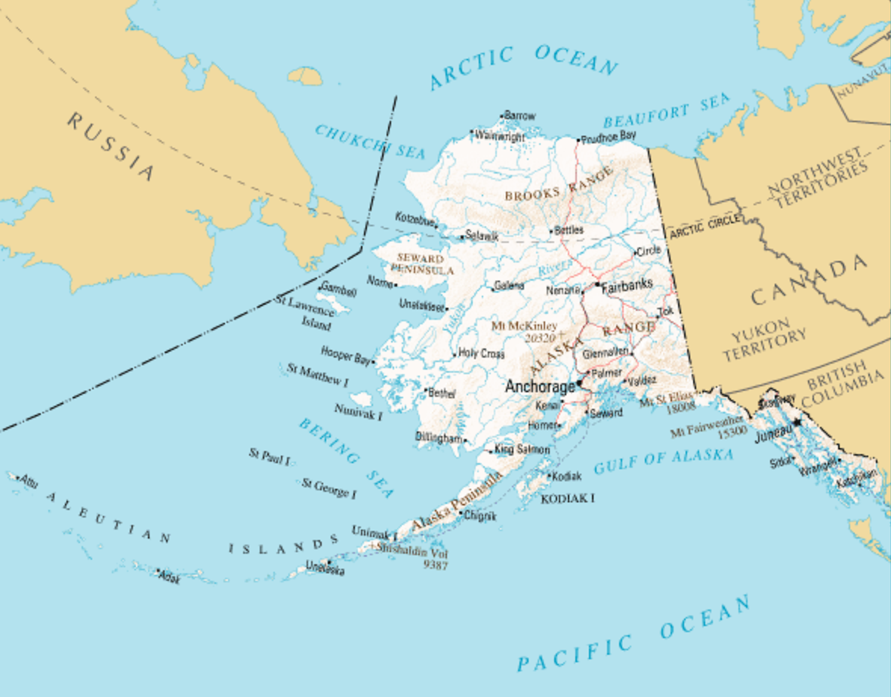

3. What are the two US states not bordered by another US state:

_______________ _______________

4. Alaska is part of the _______________ US but not part of the _______________ US. What does that mean?

______________________________________________________________________________

______________________________________________________________________________

5. What is the capital of Alaska? _______________

6. Can you drive to the capital of Alaska? Why or why not? ____________________________
______________________________________________________________________________

7. How much bigger is Alaska than the second larger state in the US? _______________

8. Match these towns/cities to the regions they are in:

A. Anchorage i. The Interior
B. Juneau ii. The Bush (also called the Far North
C. Kodiak_______________ _______________ ________________ _______________
(on the Alaska Peninsula) or the Arctic)
D. Fairbanks iii. South Central
E. Nome iv. Southwest
v. Southeast

9. In which region does most of the population live? _______________

10. Which region is known for tidewater glaciers and extensive forests? _______________

11. Which region is known for salmon, brown bears, caribou, and marine mammals? _______________

12. Which region is known for Arctic tundra landscapes? _______________

13. Which region includes 380 native villages? _______________

14. Which body of water has one of the largest tides in North America? _______________
(One of the larger Canadian tides is the Bay of Fundy where the reversing falls are on our way to PEI in Canada.)

15. What do Alaskans call what in the lower 48 we refer to as counties? _______________

