Read http://alaska.gov/kids/learn/region.htm and complete this worksheet.

1. Fill in the names of the regions. You can call 5 & 6 by one name.
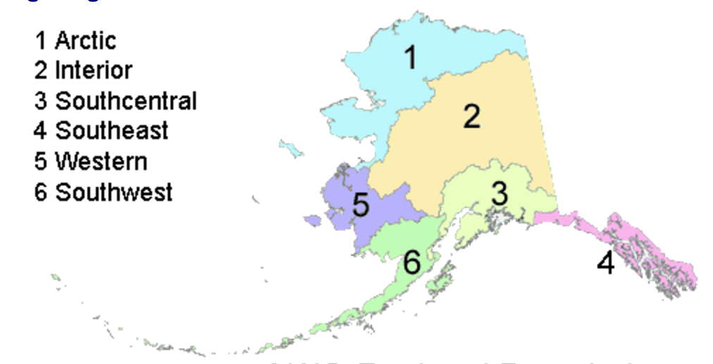
2. Give three names for the region that is number 1:

_______________ _______________ _______________

3. Write in the missing names of the cities or towns.

4. What native peoples live in the Southwest? _______________ _______________

5. What is the native tribe in the Far North? _______________

6. What is the name of the mountain range in the Far North? _______________

7. What is the name of the major river in the Interior? _______________

8. What are the native people in the Interior? _______________

9. What is the name of the highest mountain in North American, that is in the Interior?

_______________

10. What mountain range is that highest peak a part of? _______________

11. Where’s the best location for viewing the northern lights? _______________

12. Name three forms of transportation that serve Southcentral:

_______________ _______________ _______________

13. What is the name of the peninsula below Anchorage on which you can find Seward and Homer?
_______________

14. What formed the lace-type islands in Southeast? _______________

15. Name four types of animals commonly seen in Southeast’s maritime climate:

_______________ _______________ _______________ _______________

16. What is the name of the national forest in Southeast? _______________

17. What is the name of the national park in Southeast? _______________

18. What was Juneau founded during? _______________

19. What is the Alaska state nickname? _______________

20. What does Alaska means? _______________

21. What is the Alaska state motto? _______________

22. What does the Alaska state flag look like to you? _______________

23. Look up the word “fjord”. What is it? ___________________________________________

