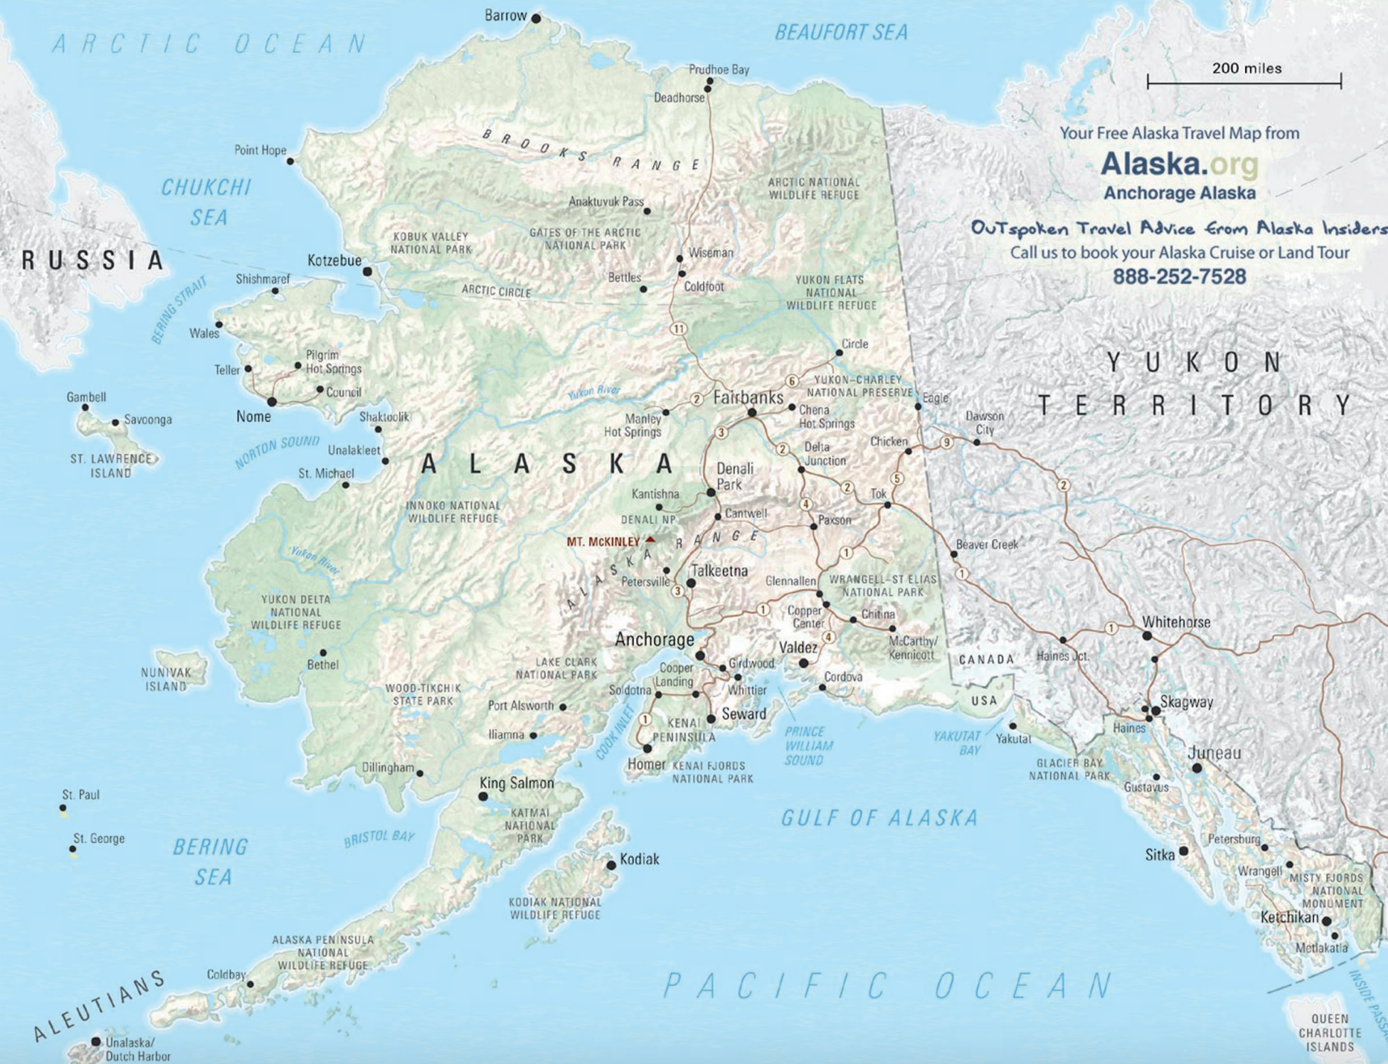
Draw our itinerary and route on this map (ask for help as you need it):

1. Label any missing cities or towns. Hints: Healy is right by Denali Park and Nenana is between Healy and Fairbanks. North Pole is just north of Fairbanks. Kenai is just west of Soldotna. Wasilla and Sutton are at the crossroad between Anchorage and Talkeetna. It may be easier to read here: http://www.alaska.org/assets/content/maps/Alaska_Map.pdf

2. Number all of our stops by writing the numerals 1 to 14 by the town or city names:
1. Juneau (fly in from Chicago and fly out to Nome)
2. Nome (fly to Sitka)
3. Sitka (fly to Anchorage, drive to Healy and all other towns unless otherwise noted))
4. Healy
5. Nenana
6. North Pole
7. Delta Junction
8. Valdez
9. Kenai
10. Seward
11. Wasilla
12. Sutton
13. Anchorage (fly to Kodiak)
14. Kodiak (fly to Anchorage and then to Chicago)

3. Draw the driving route from one city to the next. You can use a dotted line when we are flying and a solid line when we are driving. Make sure we’re driving on roads and not through water or mountain ranges.

