Read http://alaskatrekker.com/alaska/alaska-natives/ and complete the worksheet.

1. Write in the names of the native peoples that each region is known for:

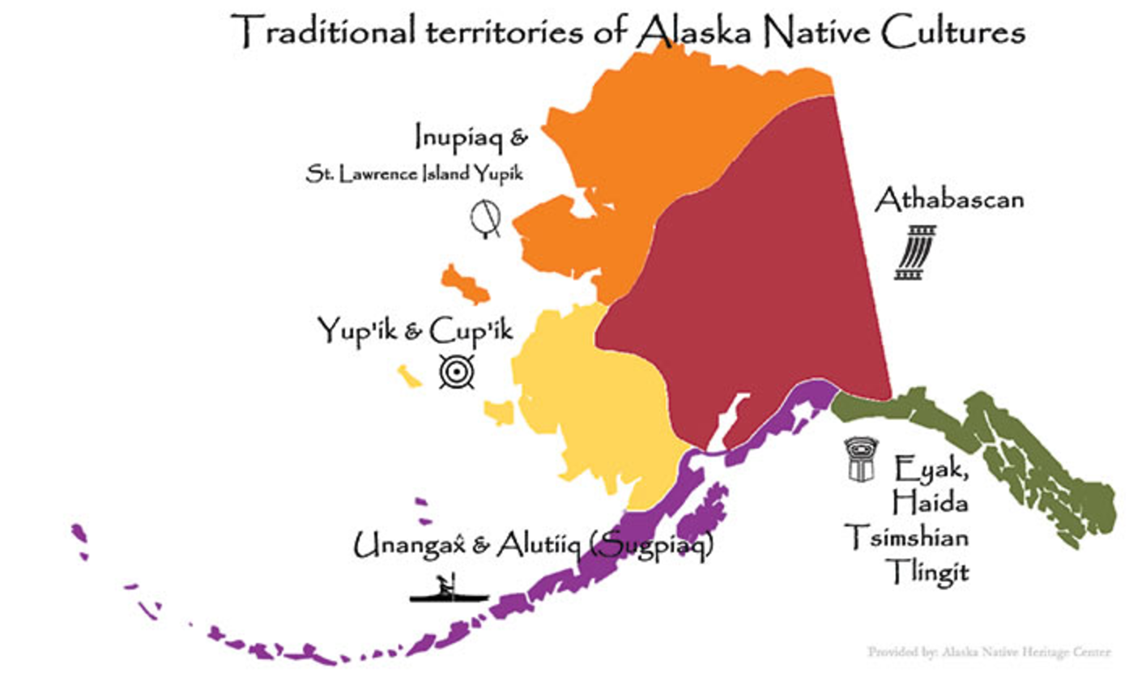
2. Where do the Tlingit and Haida live? _______________

3. In addition to potlatches, what are the Tlingit and Haida famous for carving?

_______________

4. Name four illnesses that threatened native Alaskans:

_______________ _______________ ________________ _______________

5. What percentage of the Alaskan population are Alaska natives? _______________

6. Where do the Aleuts live? _______________

7. What are Aleuts famous for weaving? _______________

8. Permanent Aleutian villages consisted of _______________ homes.

9. The Aleuts lived on _______________ waters but the Inuit were surrounded by the

________________ northern seas so the Inuit were more _______________ than the Aleuts.
10. The Inuit food, clothing, household furnishings, and fuel all come from _______________.

11. What did the Inuit used to be called? _______________

13. What does Inuit mean? _______________

14. What did the Inuit hunt in the sea?

_______________ _______________ ________________

15. What did the Inuit hunt on land?

_______________ _______________ ________________ _______________

16. How did they travel on land? _______________ and on sea? _______________

17. When did the Inuit build igloos? _______________

18. What do the Inupiat eat in addition to whale, fish, caribou, and moose? _______________

19. Where do the Yup’ik live? _______________

20. Where do the Athabascans (or Athapaskans) live? _______________

