Section A:
Read http://www.softschools.com/science/biomes/types_of_biomes/ and this vocabulary then complete these first questions:
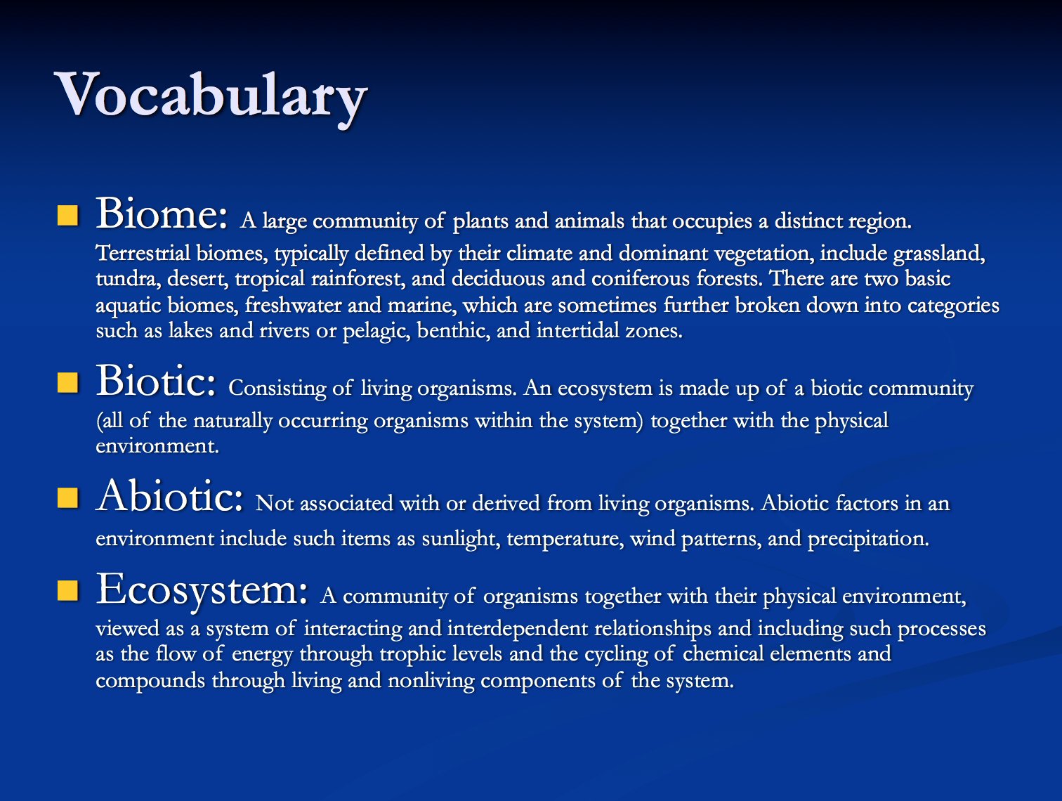

1. A biome is a large _______________ of plants and animals that occupies a distinct

_______________.

2. What are the two main categories of biomes?

_______________ _______________

3. What are the two main categories of aquatic biomes?

_______________ _______________

4. Biomes differ in their c_______________, v_______________, and a_______________

l______________.

5. What are the four main categories of terrestrial biomes?
_______________ _______________ _______________ _______________

6. What are the two categories of forest biomes?

_______________ _______________

Section B:
Read http://www.softschools.com/facts/biomes/tundra_biome_facts/171/ and this summary then complete these questions:
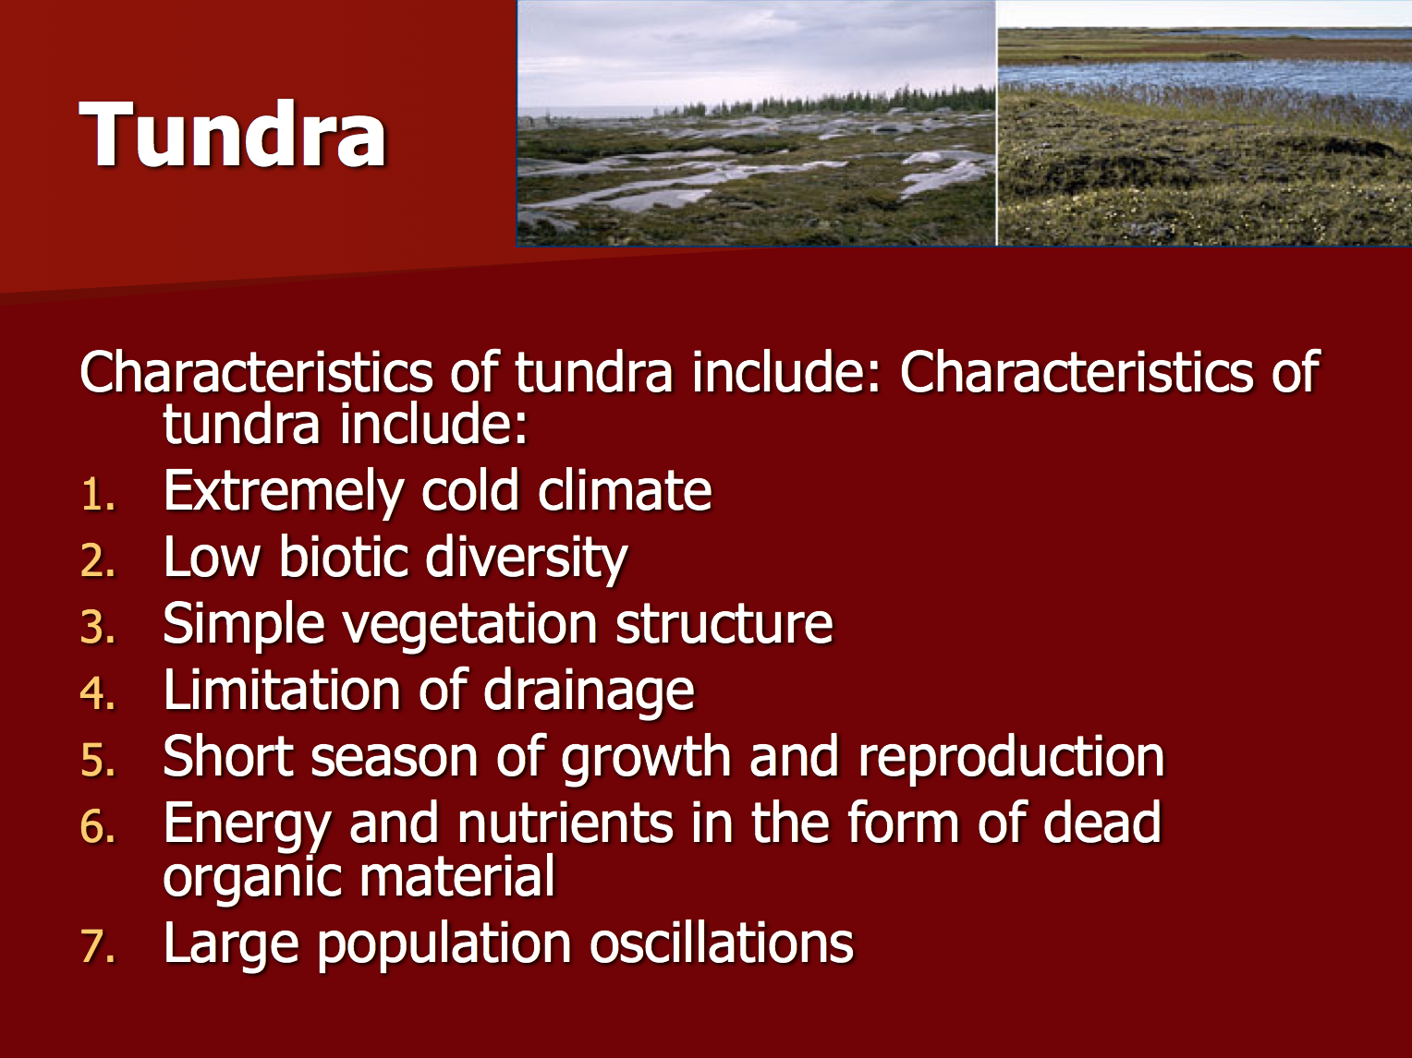

7. The tundra is the _______________est and _______________est of all biomes.

8. Are there some (granted, not many) animals and plants in the frozen tundra? _______________

9. What are the two choices for animals during the harsh tundra winter?

_______________ _______________

10. What is the largest mammal that lives in the tundra? _______________

11. There are lots of _______________ mines and rigs in the tundra.

12. What are the two categories of tundra?

_______________ _______________

Section C:
Read http://www.softschools.com/facts/biomes/taiga_biome_facts/162/ and this summary then answer these questions:
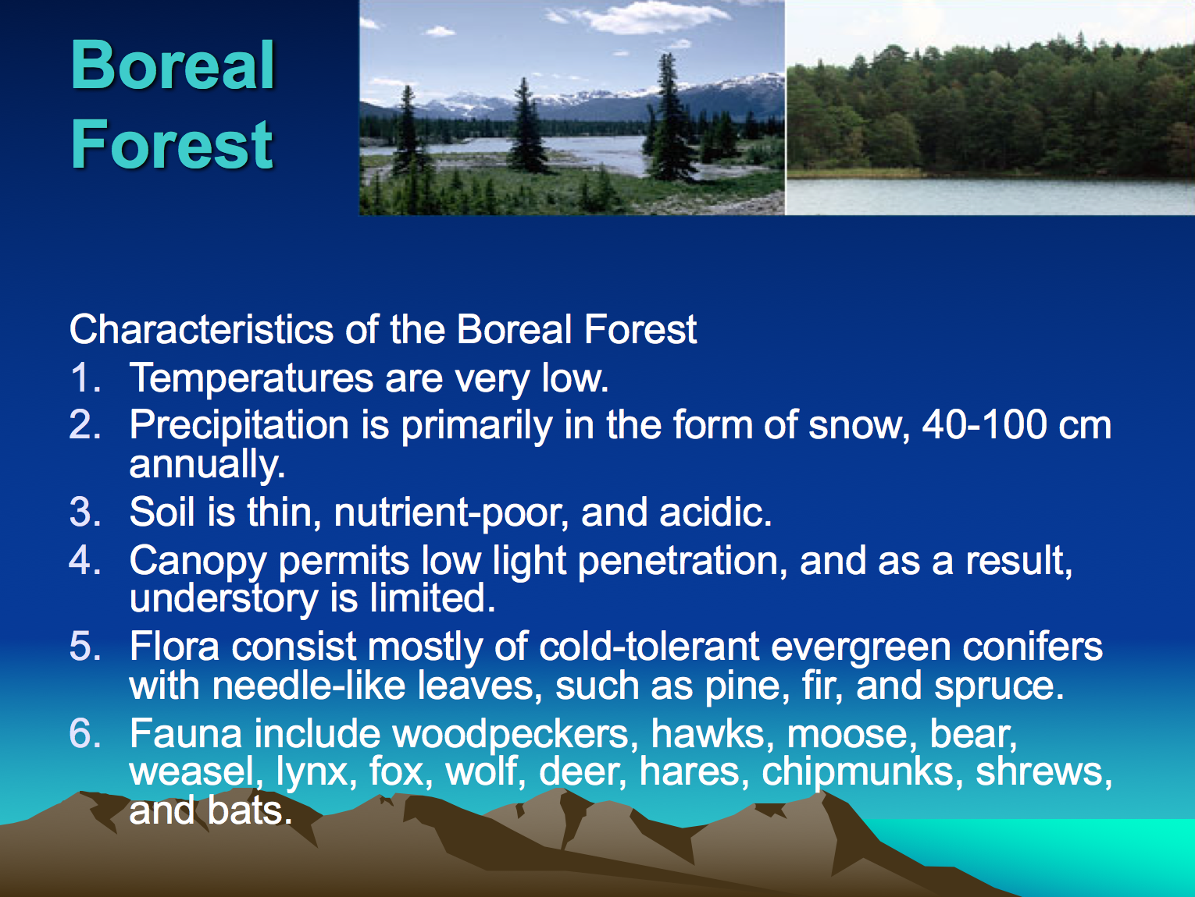

13. The taiga biome is the _______________est terrestrial biome.

14. It is located right below the _______________ biome.

15. The taiga is also called the _________________ or _______________ forest.

16. Precipitation (rain and snow) are _______________ in the taiga, so it is not as dry as the tundra nor as wet as the rainforest.

17. What is common in the taiga and necessary to rid the area of old and sick trees?

_______________

18. Is there a lot of variety in plants and trees? _______________

19. Do taiga trees lose their leaves or are they evergreens? _______________

20. There are not a lot of animals in the taiga but there are millions of _______________.

21. What are the two largest mammals to live in the taiga?

_______________ _______________

Section D:
Read http://www.softschools.com/facts/biomes/temperate_deciduous_forest_biome_facts/161/
and this summary then answer these questions:
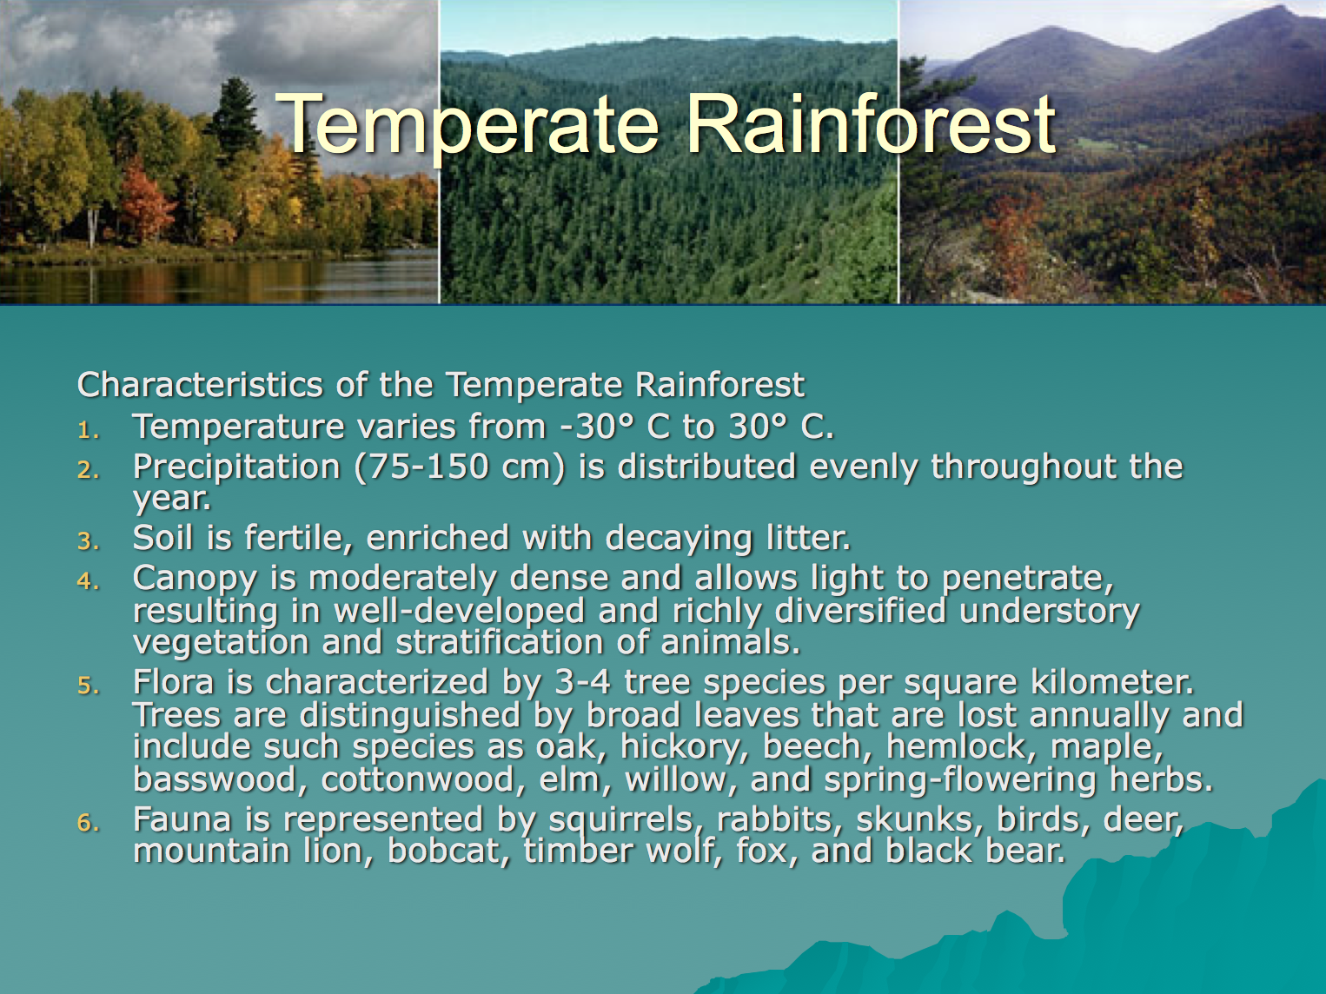

22. The temperate rainforest is also called the _______________ _______________ forest.

23. The temperate rainforest experience all four _______________.

24. Are temperatures extremely hot or extremely cold in the temperate rainforest?

_______________

25. Temperate rainforests are the _______________est biome.

26. The trees are not coniferous like in the taiga (which don’t lose their leaves) and they do lose their leaves so they are called _______________.

27. What are the three largest mammals in the temperate rainforest?

_______________ _______________ _______________

28. What provides shelter, food, and water for animals in the temperate rainforest?

_______________

Section E:
Use this map and previous maps from previous worksheets to answer the last set of questions:
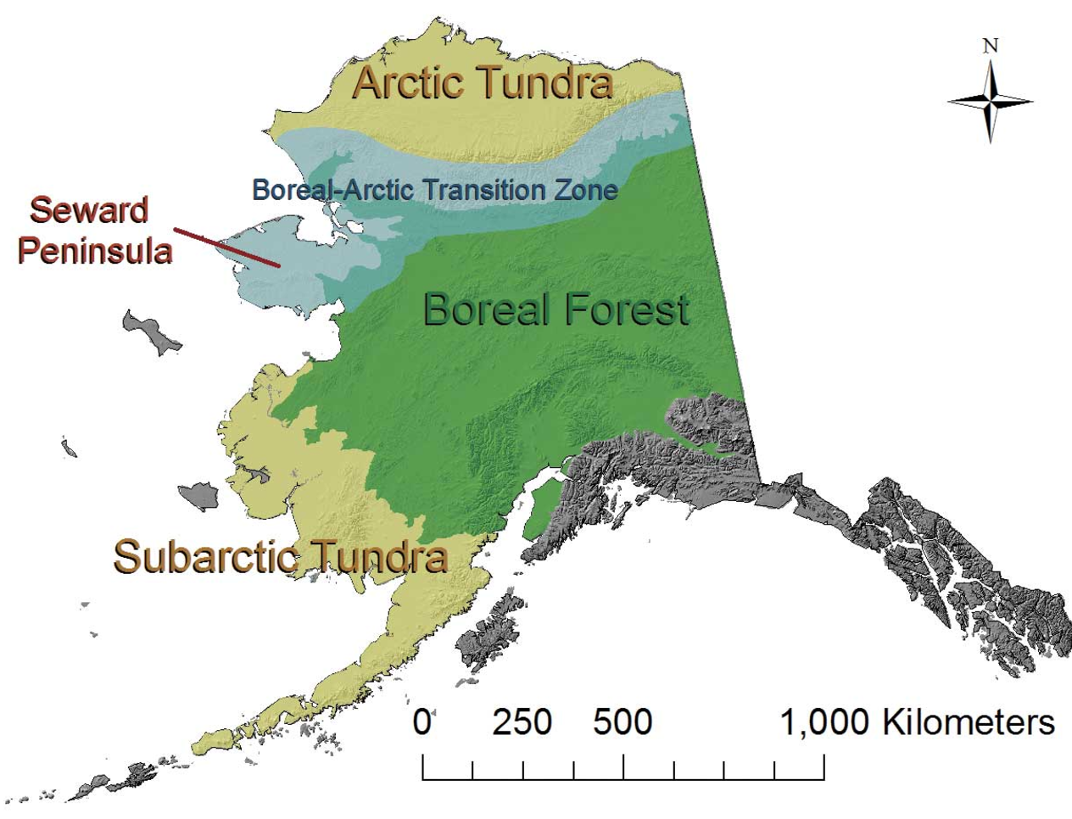

30. Write in the biomes in the correct boxes on the map.

31. Match Alaska’s bears to the biomes:
A. brown bear (grizzly or Kodiak) i. tundra
B. black bear ii. taiga
C. polar bear iii. temperate rainforest

32. Write these three biomes in the box where they belong in the chart:

temperate rainforest taiga tundra

 | wettest | moderate | driest
coldest

most extremes in hot and cold

most temperate (least variation in temperature)

33. Write the names of the cities or towns into the correct biome column based on your knowledge from the maps:
temperate rainforest | taiga | tundra

Cities and towns: Juneau, Nome, Sitka, Healy, Nenana, North Pole, Fairbanks, Delta Junction, Valdez, Kenai, Seward, Wasilla, Sutton, Anchorage, Kodiak

