Read http://www.alaskakids.org/index.cfm/know-alaska/Alaska-Geography and answer this first set of questions:

1. Alaska forms the top of the rim of the famous _______________ of _______________.

2. What two natural disasters occur along this rim?

_______________ _______________

3. Two major _______________ _______________ collide making Alaska one of the most

active _______________ zones on the planet.

Read http://www.alaskakids.org/index.cfm/know-alaska/Alaska-Geography/Earthquakes and answer this next set of questions:

4. _______________ earthquakes occur in Alaska than anywhere else in the United States.

5. Giant slabs of rock, one continental and one oceanic, crash into each other and remind us

that the Earth is still _______________.

6. Most of the quakes in Alaska are not _______________.

7. The _______________ Scale measure earthquakes.

8. The second largest quake ever recorded in the world happened in Alaska on

_______________ (date).

Read http://www.alaskakids.org/index.cfm/know-alaska/Alaska-Geography/Glaciers and answer this next set of questions:

9. If you put all of the glaciers in the Lower 48 together, they wouldn’t be as _______________ as just one of Alaska’s glaciers.

10. Glaciers are often described as _______________ ________________ of

_______________.

11. Glaciers are made up of ________________, _______________, and _______________.

12. What pulls these large, heavy slabs of ice down the mountains where they form?

_______________

13. Why do glaciers look blue? ____________________________________________________

14. What are the two main types of glaciers?

_______________ _______________

15. How many glaciers are in Alaska? _______________

16. How many have been named? _______________

17. What Sound has more active tidewater glaciers than anywhere else in the world?

18. What is the name of the glacier in Juneau? _______________

Read http://www.alaskakids.org/index.cfm/know-alaska/Alaska-Geography/Mountains and answer this next set of questions:

19. How many different mountain ranges spread across Alaska? ________________

20. What are the names of the four major mountain ranges?

_______________ _______________ _______________ _______________

21. Which range is Denali (or Mt. McKinley) in? _______________

22. More than half of the tallest mountains in Alaska are found in which range?

_______________

23. Which range forms a natural border between the arctic and the interior regions?

_______________

24. Which range stretches along the Alaska Peninsula through the Aleutian Islands?

_______________

25. Label the four major mountain ranges in Alaska based on what you’ve learned:

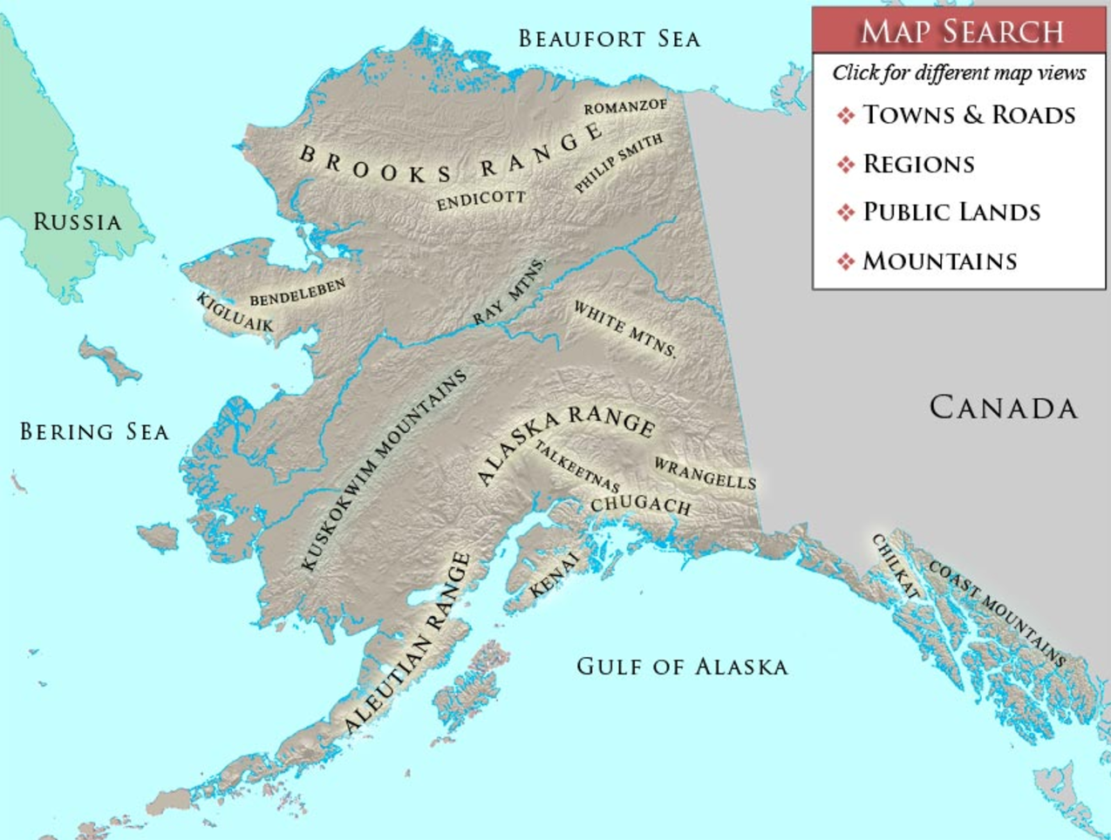
Brooks Range
Alaska Range
Aleutian Range
Coast Range

