1. Write the animal’s name below each picture. There is a list to choose from at the end of the pictures.
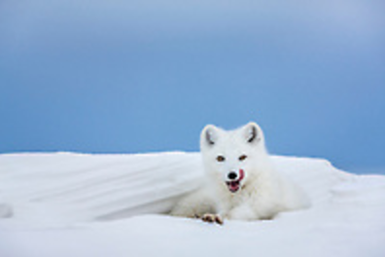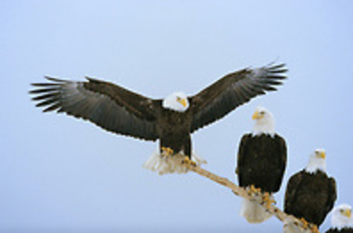

A. _______________ B. _______________
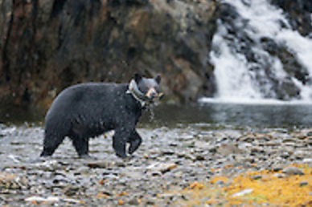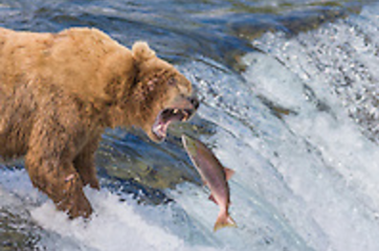

C. _______________ D. _______________
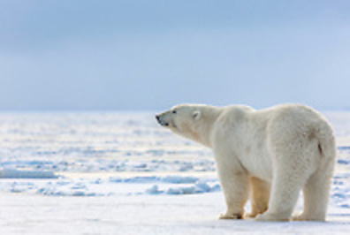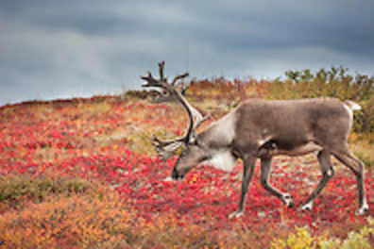

E. _______________ F. _______________

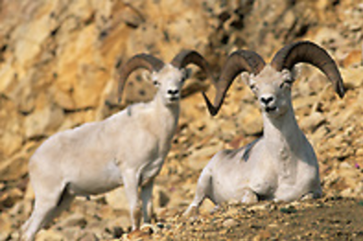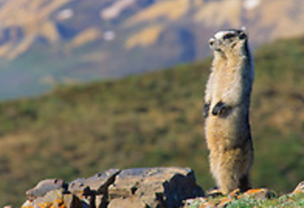

G. _______________ H. _______________
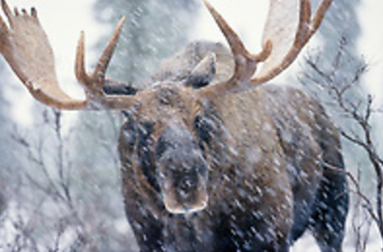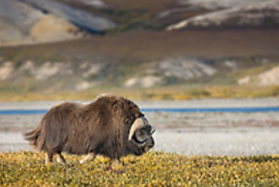

I. _______________ J. _______________
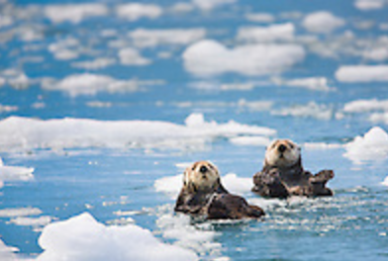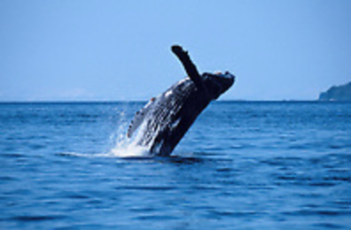

K. _______________ L. _______________

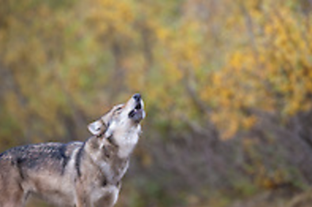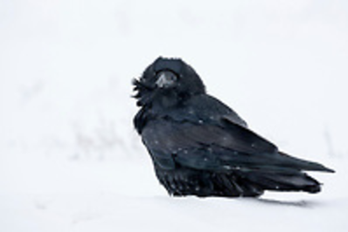

M. _______________ N. _______________
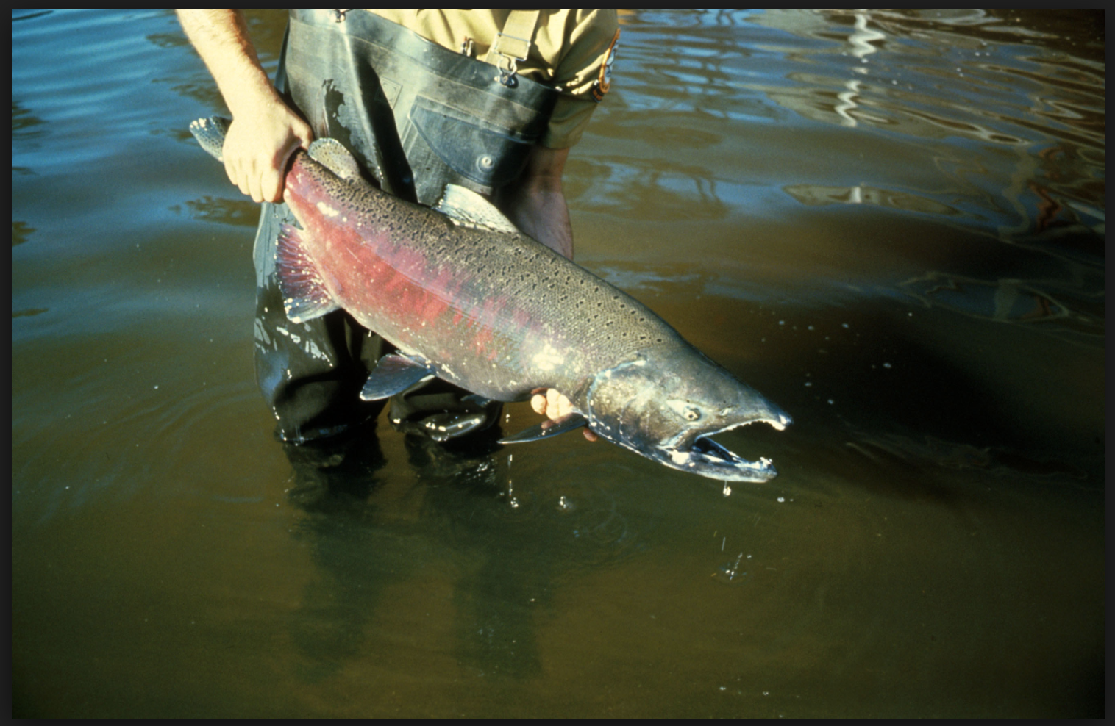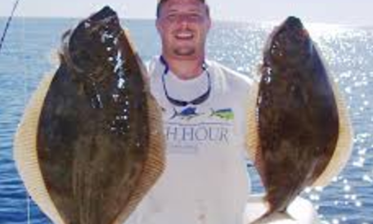

O. _______________ P. _______________
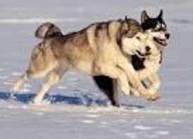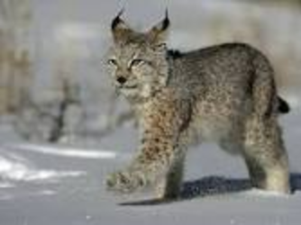

Q. _______________ R. _______________

polar bear, black bear, brown bear (grizzly or Kodiak), moose, Dall sheep, raven, bald eagle, lynx, arctic fox, marmot, wolf, whale, caribou (reindeer), muskox, salmon, halibut, husky, sea otter

2. Match each description below to a picture above.

a. large squirrels that live burrows in grasslands and hibernate in the winter
b. a canine relative native to remote areas that hunt in packs
c. a carnivore who lives mainly in the arctic and eats seals
d. the smallest bear, an omnivore, that eats berries and leaves
e. a carnivore with a larger range that eats mostly fish, like salmon
f. a feline relative with tufts on its ears
g. a general name for strong, fast, hearty runners
h. a fish with pink, firm flesh
i. a fish with flaky, white flesh
j. a black bird, bigger than a crow, with a deep croaking call
k. a brown bird with a white head with a high pitched scream
l. a marine mammal, larger than its river cousin, that forages for food on the ocean floor close to shore
m. a marine mammal that travel in groups in open ocean, raising their young entirely at sea
n. a member of the goat family whose Inuktitut name means “bearded one” and whose hair makes warm sweaters
o. a white sheep with curved horns that are better climbers than mountain goats
p. the largest member of the deer family, can be aggressive when cornered
q. a slightly smaller member of the deer family known for elaborate antlers
r. a smaller mammal with warm fur that blends into its environment that hunts and eats even smaller mammals like lemmings as well as fish, birds, berries, insects, and seaweed

