## Washington Irving’s

## “The Legend of Sleepy Hollow”

## By Stevens Puppets

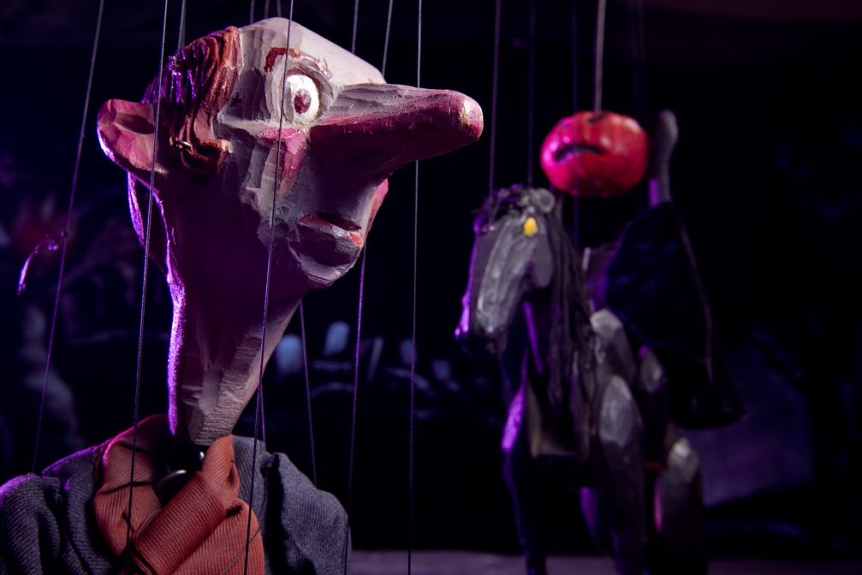

An Educator’s Guide

### Welcome to the show!

Join Ichabod Crane, and the Van Tassel Family, in this student-friendly version of Washington Irving’s classic piece of literature. Set against the backdrop of post-colonial Hudson Valley, New York, this comedic iteration of the classic story follows the adventures of the new school master, Ichabod Crane, and his ill-fated love for Katrina, the daughter of a local immigrant farmer, Baltus Van Tassel. With help from the favored suitor, Brom Bones, Baltus and his son, Fritz, play on the school master’s overactive imagination and plot to drive him out of town. They tell Ichabod the story of “The Headless Horseman” and upon wandering home through a deserted cemetery, Ichabod is forced to decide if this tale is real…or all in his head. Featuring intricately carved wooden marionettes, hand painted scenery, and underscored by classical music, America’s first short story has been masterfully adapted by Martin Stevens and Daniel Raynor.

## Before the show

### A cartoon of a person riding a horse Description automatically generatedActivate Schemata

*Engage in a discussion with your students at their level to help them recall what they already know about the story of “The Legend of Sleepy Hollow” and Dutch settlements in the Hudson Valley in post-Revolutionary New York and to predict what they will see. Use questions like this to begin the discussion.*

* What characters will be in the story? What might they look like? What might they act like? How might they be related?
* Where will the story be set? (In a house? Outside? In a cemetery?)
* When will the story be set?
* What will be happening at the beginning of the story?
* What will be happening in the middle of the story?
* What will happen at the end of the story?
* What role might the Headless Horseman play in the development of the story?
* What characters do you expect to see?
* What kind of clothes might they wear?
* Where is New York? Is it in the United States? How is it different than where we live?
* How is the post-Revolutionary era different than our own?
* Are you familiar with this story? Where have you seen it before?

**Academic Standards that connect to the performance experience.**

* Describe play-acting, pretending, and real life.
* Compare a story that is read to one that is acted out.
* Identify how the elements of place and time can change a story.
* Describe characters and plot development discovered during dramatic play.
* Demonstrate how the parts of the story go together by acting out a story with a beginning, middle, and end.
* Identify characters in stories from various cultures.
* Re-tell a story, demonstrating respect, from a culture other than one's own.
* Identify similarities between plays and stories.
* Describe a character in a story and tell why the character is important to the story.
* Communicate with others the concept of dramatic conflict and resolution in stories using dramatic play.
* Explain the difference between the stage, backstage, and audience areas.
* Identify universal characters in stories from different cultures.
* Discuss why costumes and makeup are used in a play.
* Understand how cultural differences are expressed through character, environment, and theme.
* Identify geographical or cultural origins of stories.
* Identify interpersonal skills that are learned through participation in a play.
* Discuss differences between stories that are presented in different modes or time periods.
* Devise a story about an age-appropriate issue and explore different endings.
* Discuss the concept of "willing suspension of disbelief" used in theatre to help create the illusion of real life in performances.
* Explore how theatre is used to understand different cultures.
* Discuss alternate performance possibilities of the same character in the same play.
* Define the visual elements that must be conveyed dramatically to make a scene effective.
* Make a list of types of props that might be found in a play.
* Explore how theatre can communicate universal truths across the boundaries of culture and language.
* Recognize theatre works as a reflection of societal beliefs and values.
* Create a new ending for a familiar story.
* Describe how a theatrical activity can entertain or instruct an audience.
* Discuss the ways in which theatre experiences involve empathy and aesthetic distance.
* Explain how a performance would change if depicted in a different location, time, or culture.
* Explore potential differences when performing works set in a variety of historical and cultural contexts.

### Theater Etiquette

*The main curtain will open during the show and the action will take place on the center of the stage. The curtain will close periodically between individual scenes to allow for changes of scenery and set pieces/props and then re-open on a new scene. The puppeteer will come out in front of the stage before the show to introduce it and after the show to take a bow, to demonstrate a marionette, and to answer some questions. Depending on space and time, the puppeteer will invite the teachers to bring their classes behind the stage to see the puppets and the backstage area and to ask more questions.*

Sit on your bottom so the people behind you can see the show.

Remain quiet while a scene is in action so everyone can hear the dialogue.

Clap during scene changes to show you enjoyed the previous scene.

Laugh out loud when you think something in the show is funny.

After the show, clap when the puppeteer comes out in front of the stage to show you appreciated the puppeteer’s performance and the artist’s work.

Remain seated and quiet while the puppeteer demonstrates how a marionette works so everyone can see and hear.

Raise your hand if you would like to volunteer when the puppeteer asks someone to help demonstrate a puppet.

Clap for the volunteer when invited to in order to show you appreciate their bravery and participation and you think they did a good job.

Raise your hand to ask a question of the puppeteer when invited.

Wait for instructions and to be dismissed before getting up after the show.

When invited backstage, stay in line with your classmates and with your teacher, be careful to look with your eyes but please don’t touch anything and feel free to ask more questions of the puppeteer backstage about the show, the puppets, or the stage, or anything else you’re interested in.

###### A red and white logo with a person playing basketball Description automatically generatedAcademic Standards for Theater Etiquette

## Demonstrate appropriate audience behavior at a live performance.

## Exhibit appropriate audience etiquette and response.

## Exhibit the behavior necessary to establish audience etiquette, response, and constructive criticism.

## Demonstrate effective audience etiquette and constructive criticism for a live performance.

## Exhibit proper audience etiquette, give constructive criticism, and defend personal responses.

## Describe the difference in responsibilities between being an audience member at live or recorded performances.

* Describe the responsibilities of audience members, to the actors and each other, at live and recorded performances and demonstrate appropriate behavior.

Information relating to performance genre and content

*Use this information and these resources about the story, the company/performers, and marionettes with your students before and after the performance. For example, the original texts and illustrations can be used for textual and visual comparisons of the different versions, how the Dutch settlements of the Hudson River Valley in post-Revolutionary setting affected the story. Information about marionettes can be used to discuss how this was the same or different from live actors or animated versions.*

“The Legend of Sleepy Hollow” was originally written by Washington Irving in 1820 and set in 1790, with many variations arising as the story and iconic characters, like Ichabod Crane and the Headless Horseman, achieved the level of folk stories. Washington Irving was one of the earliest American authors to achieve a level of fame and to begin establishing a distinct tradition of American literature. He is often cited as the author of America’s first short stories.

For a synopsis and history of versions and variations: https://en.wikipedia.org/wiki/The_Legend_of_Sleepy_Hollow

For the original Irving text (to read or to listen to): http://publicliterature.org/books/legend_of_sleepy_hallow/1

For an essay about the area and story inspiration written by Washington Irving: https://archive.is/20130111004140/http://henrysteiner.com/DIRcomm/sleepyhollow/article.htm

Stevens Puppets’ production was written by Martin Stevens in 1965, based on the story and characters from the original text by, Washington Irving, and adapted by Dan Raynor. Martin Stevens hand-carved the wooden marionettes and jointed them and strung them, and built the set pieces and props. His wife, Margi Stevens, painted and costumed the marionettes and painted the scenery. The original 1965 voices were replaced in 2000, recorded digitally in a studio and feature the talents of Raynor family members and friends. Dan Raynor edited the recording and added music and sound effects.

Stevens Puppets, and its founders Martin and Margi Stevens, are important in the history of American puppetry and are featured in museums around the country. More information about the company, the founders, and the shows can be found at: <http://www.stevenspuppets.com/>

Marionettes are a subset of puppets which are suspended from wooden controllers and controlled by strings. For more information about marionettes: <https://en.wikipedia.org/wiki/Marionette>

## Additional pre-show activities

*Before or after the performance, a unit exploring New York, Dutch settlements and the post-Revolutionary era would be appropriate. Related content would include*

* *the different biospheres and climates between the state of New York and your local area*
* *the difference between the settlements of New York and your local area, specifically the Dutch, Spanish, and Native American influences.*
* *Washington Irving and the town of Sleepy Hollow. What is the difference between Sleepy Hollow and Tarrytown?* [*Washington Irving on Sleepy Hollow*](https://l.facebook.com/l.php?u=https%3A%2F%2Farchive.is%2F20130111004140%2Fhttp%3A%2F%2Fhenrysteiner.com%2FDIRcomm%2Fsleepyhollow%2Farticle.htm&h=ATMe8YXnlhik6YU6jCmIYFrnj9V8MuGbcRzVWBJaQ0Us3FclLRY7ujlHKa45RwyK6ROM0DXo2-0U1geLMUI-cDNQaupkgWfxlFEJycJ4yUxfFG2B)
* *The history of New York in post-Revolutionary times*

*After the show, you could ask students to identify elements of Dutch settlements that played an important part in the show and how the story and the characters and the visual elements were different because it was set in the post-Revolutionary era.*

*You can use this unit of guided discovery for students to complete individually or in groups or to design your own unit about Washington Irving, the post- Revolutionary era, and the fictional town of Sleepy Hollow.*

**Academic Standards that relate to the activity if applicable**

## Identify how the elements of place and time can change a story.

* Identify characters in stories from various cultures.
* Re-tell a story, demonstrating respect, from a culture other than one's own.
* Identify universal characters in stories from different cultures.
* Discuss why costumes and makeup are used in a play.
* Understand how cultural differences are expressed through character, environment, and theme.
* Identify geographical or cultural origins of stories.
* Discuss differences between stories that are presented in different modes or time periods.
* Explore how theatre is used to understand different cultures.
* Explore how theatre can communicate universal truths across the boundaries of culture and language.
* Recognize theatre works as a reflection of societal beliefs and values.
* Explain how a performance would change if depicted in a different location, time, or culture.
* Explore potential differences when performing works set in a variety of historical and cultural contexts.
* Interpret words and phrases as they are used in a text, including determining technical, connotative, and figurative meanings, and analyze how specific word choices shape meaning or tone.

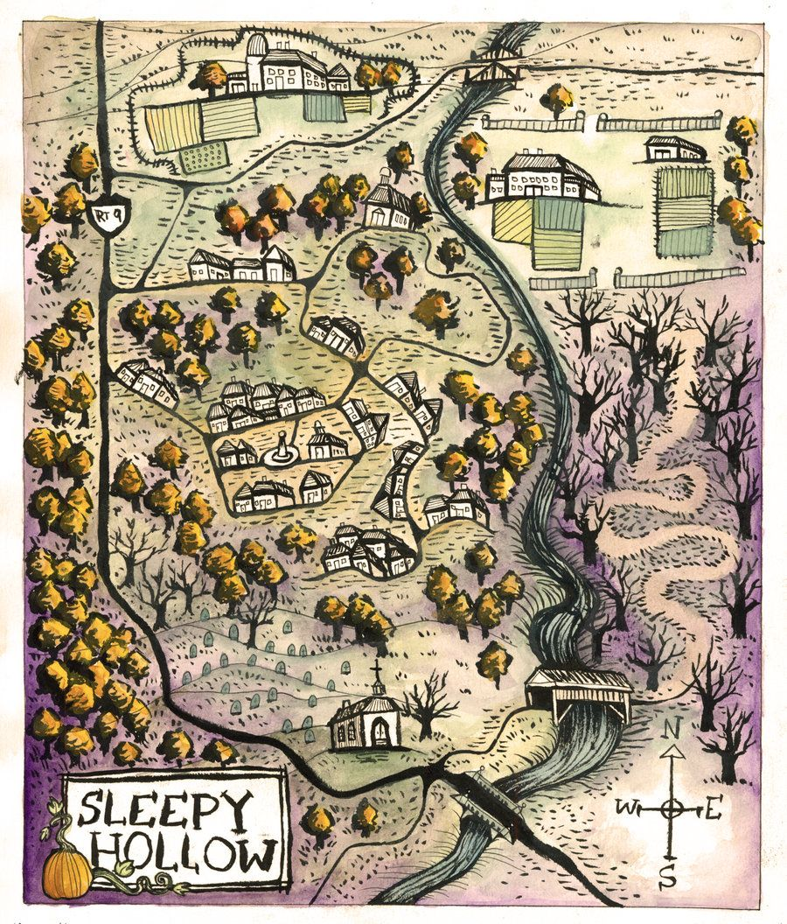

## After the show

### Post-show activities connected to the Academic Standards

Language Arts, Science (geography), Social Studies (different cultures, social justice, conflict resolution), History Activities

*Review the discussion questions for activating schemata and prediction and discuss how the story met their expectations and how it surprised them. At your students level, engage in a continuing discussion with questions like these:*

* What in the story seemed unreal or unlikely to you? Why? Why do you think the author did that?
* How does the post-Revolutionary schoolhouse differ from modern classrooms?
* Why do you think Ichabod Crane was an outcast in the town?
* Why do you think Brom Bones and Ichabod Crane have such a strong rivalry?
* How were Mama and Katrina treated by the men in the story? What does this suggest about how women were regarded in this time period? How is this different from our own era?
* What is the importance of food in this story? What is the importance of eating together in this story?
* What does the story tell you about wealth and the transference of wealth? About sharing? About justice and cruel jokes?
* What does the story tell you about community ties, legends and ghost stories, and bullying?
* Who do you think the Headless Horseman was?
* How do you think stories teach lessons? Is this important to a society? Do you think it’s the most effective method?
* Do Mama, Papa, Katrina, Brom and Ichabod seem like traditional males and females to you? Why or why not?
* How was this story similar and different from the other Sleepy Hollow stories you’ve seen, heard, or read? Why do you think those choices were made? How is the ending different? Why is that important?

**Academic Standards that relate to the activities**

* Describe play-acting, pretending, and real life.
* Compare a story that is read to one that is acted out.
* Identify how the elements of place and time can change a story.
* Describe characters and plot development discovered during dramatic play.
* Demonstrate how the parts of the story go together by acting out a story with a beginning, middle, and end.
* Identify characters in stories from various cultures.
* Re-tell a story, demonstrating respect, from a culture other than one's own.
* Identify similarities between plays and stories.
* Describe a character in a story and tell why the character is important to the story.
* Communicate with others the concept of dramatic conflict and resolution in stories using dramatic play.
* Explain the difference between the stage, backstage, and audience areas.
* Identify universal characters in stories from different cultures.
* Discuss why costumes and makeup are used in a play.
* Understand how cultural differences are expressed through character, environment, and theme.
* Identify geographical or cultural origins of stories.
* Identify interpersonal skills that are learned through participation in a play.
* Discuss differences between stories that are presented in different modes or time periods.
* Devise a story about an age-appropriate issue and explore different endings.
* Discuss the concept of "willing suspension of disbelief" used in theatre to help create the illusion of real life in performances.
* Explore how theatre is used to understand different cultures.
* Discuss alternate performance possibilities of the same character in the same play.
* Define the visual elements that must be conveyed dramatically to make a scene effective.
* Make a list of types of props that might be found in a play.
* Explore how theatre can communicate universal truths across the boundaries of culture and language.
* Recognize theatre works as a reflection of societal beliefs and values.
* Create a new ending for a familiar story.
* Describe how a theatrical activity can entertain or instruct an audience.
* Discuss the ways in which theatre experiences involve empathy and aesthetic distance.
* Explain how a performance would change if depicted in a different location, time, or culture.
* Explore potential differences when performing works set in a variety of historical and cultural contexts.
* Determine central ideas or themes of a text and analyze their development; summarize the key supporting details and ideas.
* Analyze how and why individuals, events, and ideas develop and interact over the course of a text.
* Interpret words and phrases as they are used in a text, including determining technical, connotative, and figurative meanings, and analyze how specific word choices shape meaning or tone.

### Puppet Theater Activities

*Have students discuss, perhaps draw/diagram, the performance venue with the puppet stage in it and identify where the audience was, where the puppets were, where the puppeteer was. Identify where the speakers and lights were. Identify where the puppets hung backstage. How did the puppeteer handle the marionettes when there were more than two on stage? Did anyone see how small the stage and the show packed up before or after the show? Why is that important?*

*How did the puppeteer control the marionettes? Where were the jointed so they could move? How were the head/neck joints different on the horses and on the people? How were the shoulder joints different than the elbow joints and how were the thigh joints different than the knee joints? Why? Notice how these joints work differently on your own body. Which joints move which way and in which ways can each joint not move?*

*What did you notice about how the puppets were carved and painted? Were there colors on the puppets that were unnatural or looked like make up? Why do you think these were used? How do you think the pumpkin worked at the end? How did the Horseman throw it?*

**Academic Standards that relate to the activity.**

* Explain the difference between the stage, backstage, and audience areas.
* Discuss why costumes and makeup are used in a play.
* Define the visual elements that must be conveyed dramatically to make a scene effective.

### Storytelling Activities

*Individually or in groups, rewrite or act out the story with different endings or set in a different distinct place. How would that change the characters that would be included? How would that change the story or the dialogue?*

**Academic Standards that relate to the activity.**

* Identify how the elements of place and time can change a story.
* Demonstrate how the parts of the story go together by acting out a story with a beginning, middle, and end.
* Identify characters in stories from various cultures.
* Identify universal characters in stories from different cultures.
* Identify geographical or cultural origins of stories.
* Discuss differences between stories that are presented in different modes or time periods.
* Devise a story about an age-appropriate issue and explore different endings.
* Create a new ending for a familiar story.
* Explain how a performance would change if depicted in a different location, time, or culture.
* Explore potential differences when performing works set in a variety of historical and cultural contexts.

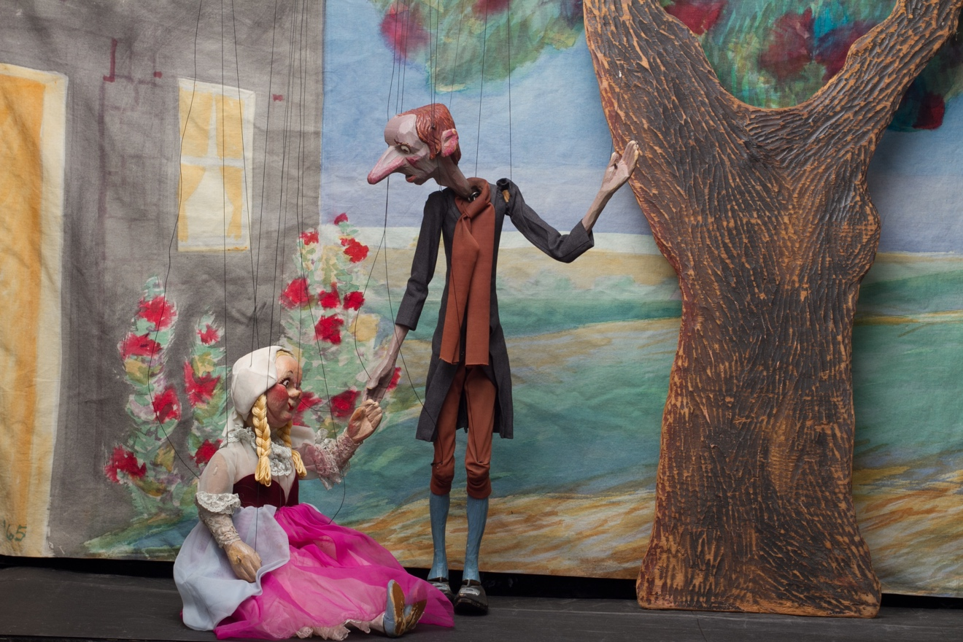

### Bibliography

https://en.wikipedia.org/wiki/The_Legend_of_Sleepy_Hollow

http://publicliterature.org/books/legend_of_sleepy_hallow/1

https://archive.is/20130111004140/http://henrysteiner.com/DIRcomm/sleepyhollow/article.htm

### <http://sleepyhollowcemetery.org/>

<https://www.imdb.com/title/tt0041094/>

<https://en.wikipedia.org/wiki/Old_Dutch_Church_of_Sleepy_Hollow>

<https://en.wikipedia.org/wiki/Sleepy_Hollow,_New_York>

<https://www.gradesaver.com/the-legend-of-sleepy-hollow/study-guide/summary>

Stevens Puppets promo video for “The Legend of Sleepy Hollow”:  
<https://youtu.be/dF0IiQhmIOg>

Stevens Puppets tours fully-staged productions of fairy-tales and classic children’s literature, featuring hand-carved wooden marionettes in front of colorfully hand-painted scenery. The charming puppets come alive in their miniature worlds, transporting their audiences through magical journeys of endearing stories, raucous laughter, and artistic beauty. The puppeteers give life to their little actors, weaving a spell of childhood over audiences of all ages, as they invite everyone along for a trip through “once upon a time.”

Stevens Puppets was founded in 1933 by the Peabody Award winning Martin Stevens, preeminent American puppeteer and founder of the Puppeteers of America. With his wife, Margi, Mr. Stevens created ground-breaking touring marionette shows which are featured in books, in museums, and on tour. Mr. Stevens’ marionettes and stage design have influenced generations of puppeteers in America and abroad, often cited as artistic benchmarks and industry standards.

Dan and Zan Raynor, the owners, have been with Stevens Puppets for over 20 years, each coming from live theatre backgrounds of acting and directing professionally. Dan holds a Bachelor of Arts degree in Theatre and Zan holds a Master of Theology with a doctorate in Canon Law. Dan has taught theatre at the Northwest Arkansas Academy of Fine Arts and directed professionally for theatres in several states, including televised events in California. He has performed with and directed many professional musicians like Neil Young and Huey Lewis, as well as acting professionally with many theatre companies in California. In addition to performing on stage as an actor and dancer, Zan has directed high school and college theatre programs, as well as designing lights, costumes, and choreography for numerous theatre companies in the Midwest and Northeast.  Zan has taught every level of school, from Montessori preschool through University classes. She has been a high school principal as well as theatre and Latin teacher. They divide their time between studio artwork, both original and restoration, training other performing artists, managing complex tours, and performing themselves all around the country at schools, libraries, festivals, and fairs.

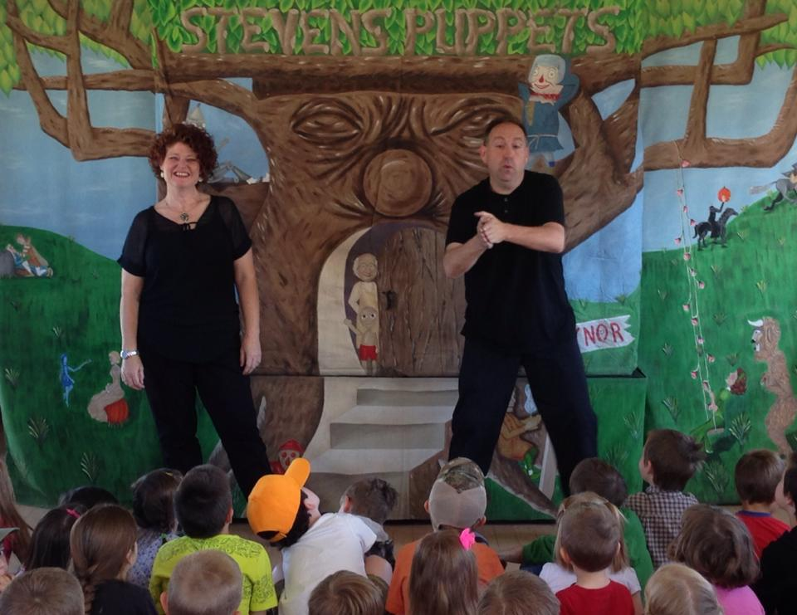

Mindful that they are stewards of this important legacy, Dan and Zan Raynor lovingly restore the original Stevens’ productions, ensuring that future generations continue to enjoy these historic treasures. They also create new productions of classic stories with hand-carved casts of characters in the tradition of the master and manage tours throughout the country performed by puppeteers they have personally chosen and apprenticed.

Dan and Zan have recently completed the restorations of “The Sleeping Beauty”, Rumplestiltskin”, “The Legend of Sleepy Hollow”, “Aladdin”, and “The Wizard of Oz”. These marionette plays feature Martin and Margi Stevens’ original puppets, Margi’s period costumes, the Stevens’ hand painted scenery, all lovingly and authentically restored or re-created by Zan and Dan Raynor. Fun fact. The “fly-apart” marionette of Rumplestiltskin was the first of its kind, an original innovation of Martin Stevens and a keystone of his company’s patrimony.